Design Documentation

Unix4UX

##### Brianna Buttaccio, Tiffany Ellis, Matt Fitzgerald, Duncan Okes, Daniel Ruano, and Nathan Wunderlich

Table of Contents

Introduction 6

Goals 6

Content Model 7

Unix Introduction 7

Why Unix? 7

Brief History 7

Starting the Terminal 7

Navigation 8

Basic UNIX Commands 9

Important Unix Flags 9

Quiz 10

Directories and Files 11

Introduction to File Structure 11

Absolute and Relative Paths 11

Files 11

Directories 13

Quiz 13

Ownership and Permissions 14

Quiz 16

Program and Installation 18

Vim 18

Atom 19

Brackets 19

FileZilla 19

Quiz 19

About Us 21

Brianna 21

Tiff 21

Duncan 21

Nate 21

Matt 21

Dan 21

Command Index 22

Tutorial with User Interaction 23

WireFrames 24

Desktop 24

Home 24

Tutorial 26

Quiz 28

Index 29

About Us 30

Mobile 31

Home 31

Menu 32

Tutorial 33

Search 34

Quiz 35

Index 36

About Us 37

Style Guide 38

Style A 38

Color Palette 38

Title 38

Paragraph 39

Buttons 39

Image 41

Form Input 42

Header 43

Footer 44

Command Index Tabs 45

About Us 46

Row Layout 47

Example Page 50

Mobile Content 51

Style B 52

Color Palette 52

Titles 52

Paragraph 53

Buttons 53

Image 54

Form Input 54

Header 55

Footer 55

Command Index Tabs 55

About Us 56

Row Layout 56

Example Page 58

Mobile Content 59

Images 60

Personas 66

Jesse and Brenda 66

Scenario 66

Derek 66

Scenario 66

Will 66

Scenario 66

Julie 67

Scenario 67

Navigational Structure 68

Sitemap 68

References 70

Table of Figures

Figure 1: Content – Unix Navigation Commands 8

Figure 2: Content - Basic Commands 9

Figure 3: Content - Important Flags 9

Figure 4: Content - Absolute Mode 16

Figure 5: Content - Vim Text Editor Commands 18

Figure 6: Command Terminal Screenshot – Before 23

Figure 7: Command Terminal Screenshot – After 23

Figure 8: Wireframe - Desktop Home 24

Figure 9: Wireframe – Desktop Home Slide-out 25

Figure 10: Wireframe – Desktop Tutorial 26

Figure 11: Wireframe – Desktop Tutorial 2 27

Figure 12: Wireframe – Desktop Quiz 28

Figure 13: Wireframe: Desktop Index 29

Figure 14: Wireframe - Desktop About Us 30

Figure 15: Wireframe - Mobile Home 31

Figure 16: Wireframe - Mobile Menu 32

Figure 17: Wireframe - Mobile Tutorial 33

Figure 18: Wireframe - Mobile Search 34

Figure 19: Wireframe - Mobile Quiz 35

Figure 20: Wireframe - Mobile Index 36

Figure 21: Wireframe - Mobile About Us 37

Figure 22: Style A - Color Palette 38

Figure 23: Style A – Titles 38

Figure 24: Style A – Paragraph 39

Figure 25: Style A – Buttons 39

Figure 26: Style A – Buttons Hover 40

Figure 27: Style A – Image 41

Figure 28: Style A – Forms 42

Figure 29: Style A – Header 43

Figure 30: Style A - Footer 44

Figure 31: Style A - Command Index Tabs 45

Figure 32: Style A - About Us 46

Figure 33: Style A - Row1 47

Figure 34: Style A - Row2 47

Figure 35: Style A - Row3 48

Figure 36: Style A - Row4 49

Figure 37: Style A - Page Example 50

Figure 38: Style A – Mobile 51

Figure 39: Style B - Color Palette 52

Figure 40: Style B – Titles 52

Figure 41: Style B - Paragraph 53

Figure 42: Style B – Buttons 53

Figure 43: Style B - Buttons Hover 53

Figure 44: Style B – Image 54

Figure 45: Style B – Forms 54

Figure 46: Style B – Header 55

Figure 47: Style B – Footer 55

Figure 48: Style B - Command Index Tabs 55

Figure 49: Style B - About Us 56

Figure 50: Style B - Row1 56

Figure 51: Style B - Row2 57

Figure 52: Style B - Row3 57

Figure 53: Style B - Row4 57

Figure 54: Style B – Page Example 58

Figure 55: Style B - Mobile Content 59

Figure 56: Images – Logo 60

Figure 57: Images - About Us Mobile Menu Icon 60

Figure 58: Images - Home Mobile Menu Icon 60

Figure 59: Images - Index Mobile Menu Icon 61

Figure 60: Images - Search Mobile Menu Icon 61

Figure 61: Images - Tutorial Mobile Menu Icon 61

Figure 62: Images - Homepage Background Female 62

Figure 63: Images - Homepage Background Male 62

Figure 64: Images – Brianna 63

Figure 65: Images – Dan 63

Figure 66: Images - Matt 64

Figure 67: Images – Nate 64

Figure 68: Images - Tiff 65

Figure 69: Images - Duncan 65

Figure 70: Sitemap 68

# Introduction

Unix4UX is a tutorial site for users who are interested in learning more about the Unix programming language. We offer a multitude of tools on our site that advance our users’ learning experiences. These tools include information on Unix basics, file structures, how to use different programs, quizzes to test the user’s comprehension of material, and an index page composed of all the commands on our site. Our quizzes include the use of short answer questions, multiple choice questions, and select all that apply questions so that users of different learning styles can all understand the material. The index page provides a convenient way for users to get more straightforward information on specific commands they need. Unix4UX is designed to be a useful tool to users of different experience levels. Our tutorials help users who have no experience using Unix get an idea on how the commands work. Our index page helps the more advanced users who have some experience programming with Unix access information quickly. These users may be having some trouble with command syntax or knowing how a command works, and need specific information rather than an entire tutorial. The index page shows all the commands on our site and when a user clicks one, they’ll be able to learn what the specific command does and how they can use it. For those on the go, we also provide a mobile version of our site to make getting information quicker and easier.

## Goals

1. Provide a useful tool to learn and understand Unix programming for users no matter their experience level.
2. Be accessible for users to get information on a desktop, laptop, or mobile device.
3. Be a useful tool that students and hobbyists of different learning styles can learn from.

# Content Model

## Unix Introduction

### Why Unix?

Free - Almost all versions of Unix based operating systems are free and open source, while macOS (OSx) is the most popular and comes with a price premium. All Unix based OS’s share the same characteristics that separate them from Windows.

Lightweight - One of the best features of Unix based OSes is they are lightweight and can run on almost any system. Thus, you do not have to purchase an expensive machine to utilize all its capabilities.

Development Environment – It easy transfer from development to production. The transition is easy because the environment is similar to the Apache production environment, which is used for web servers on top of a Linux base.

### Brief History

UNIX is used as a blanket term when discussing operating systems that were derived from the original software. Unix was developed by Ken Thompson, Dennis Ritchie and other employees in 1970 at Bell Labs in Murray Hill, New Jersey. The original goal was to provide a portable platform for the development of software. Unix can be placed on many different systems because it was written in C. This lead to Unix spreading throughout academia and spreading commercially. Many people adapt the operating system to fit the needs of their operation. Currently, the most popular operating system that meets the Unix standard is macOS (OSx).

All of Unix is controlled by the kernel. It controls the starting and stopping of tasks, along with access to the resources on the machine. The kernel also has control over the hierarchical file system used on Unix like systems. Before the implementation and popularization of graphical user interfaces, everything done in an operating system was from a command line. Because of this ancestry, everything you need to do in Unix and Unix like operating systems can be done right from the terminal.

### Starting the Terminal

#### Windows

Using Unix on a Windows machine requires a little bit of effort, but it is doable. The standard way for logging into and using a Unix server is by means of a Secure Shell (SSH) client. Secure Shell was designed to provide better security when accessing other remote devices. SSH not only encrypts your session, it also provides better authentication and features like secure file transfer. A popular (and free) client for Windows platforms is PuTTY, developed originally by Simon Tatham. To launch a Unix terminal using PuTTY:

1. Download PuTTY from www.putty.org and install it using the default settings on your computer.
2. Once installed, double click the PuTTY icon.
3. Enter the Unix server host name in the ‘Host Name’ box, and press ‘Open’ at the bottom of the dialog box.
4. Log into the server with your username and password when prompted.

#### Mac

To open the Terminal on OS X, do the following:

1. Open your Applications folder.
2. Inside Applications, open your Utilities folder.
3. Inside Utilities, double click the Terminal icon. Your terminal should look like something like the following: Image here
4. Your terminal’s colors may be different, and you may have something different on the second line. The second line will be whatever you named your computer, followed by your username and a prompt to type commands.

### Navigation

|  |  |
| --- | --- |
| **Command** | **Action** |
| ls | Lists all filenames in your current directory |
| ls -l | Lists all files in your current directory in a long format; contains more information (permissions, file ownership, the last time it was updated) |
| cd | Short for “change directory”. You can supply file paths relative to your current directory (ex. cd Documents) or an absolute file path (ex. cd users/student/Documents) |
| cd .. | Takes you to the directory containing your current working directory. To go up multiple levels, add  /.. to the command for every desired level |
| cd ~ and cd - | cd ~ takes you back to your home directory, while cd - returns you to the previous directory you were in. |
| pwd | Short for “print working directory”. Shows you your current location in your file hierarchy. |

The following are important commands that relate to navigating files and directories in Unix:

Figure 1: Content – Unix Navigation Commands

### Basic UNIX Commands

The following are other useful Unix commands when working with file system utilities:

|  |  |
| --- | --- |
| **Command** | **Action** |
| cp [file1] [file2] | Copies a file. Can also copy a file to a directory by using a path as the second parameter. |
| cat [filename] | Reads the contents of a file. You can also concatenate the contents of other files.  Ex. cat file1 file2 file3 will add the contents of file1 and file2 to file3 |
| mv [filename] [directory path] | Moves a file to the specified directory path. mv can also be used to rename files. Ex. mv Unix will rename the file Unix to Unix. |

Figure 2: Content - Basic Commands

### Important Unix Flags

Flags are settings that enable or disable optional features of a command. The following table lists commonly used flags associated with commonly used Unix commands related to file system utilities and what functionalities they add to them:

|  |  |  |
| --- | --- | --- |
| **Flag** | **Associated Command** | **Functionality** |
| -l | ls | Long-listing: lists additional information about files in a directory, such as permissions, who owns the file, and timestamps of when the file was last accessed and updated. |
| -p | cp | Preserves permissions, ownership, and timestamps when copying files |
| -i | cp, mv | Issues a confirmation prompt before copying or moving a file. |
| -v | cp | Verbose mode: shows filenames as they are being copied |

Figure 3: Content - Important Flags

Note: If you specify more than one flag, only the final flag takes effect.

### Quiz

1.What is the command to **c**o**p**y a file?

___________cp____________

2.What is the command to **m**o**v**e a file?

___________mv___________

3.What command shows you **detailed** information about your current directory?

1. Ls
2. **Ls -l**
3. Cd
4. Cd -l

4.What command allows you to rename files?

1. Rm
2. Cp
3. **Mv**
4. Ls

5.What command shows filenames as they are being copied?

1. **Cp -v**
2. Cp -i
3. Mv -p
4. Mv -v

## Directories and Files

### Introduction to File Structure

In Unix, you will often find yourself working with files. There are essentially three types of files:

1. Regular Files
2. Directories
3. Special Files

Regular files are files which contain data, text or code. These are the usual word documents, pictures, videos, text files, compressed files, HTML code etc.

Directory files are used to store files, special files and sometimes other directories

Special files allow access to various hardware and devices on the system. It is divided into five sub categories:

1. Block File
2. Character Device File
3. Pipe File
4. Symbolic link file
5. Socket file

In this tutorial, we will be working with regular files and directories.

### Absolute and Relative Paths

A path is a distinct location to a file. In Unix, we use paths to navigate and have quicker access to files. A pathname can be absolute or relative.

A pathname is absolute if it is written in relation to the root. This means that all absolute pathnames begin with a slash (/). Example: /home/work/homework/assignment1

An absolute pathname will always yield the same result.

A relative pathname is not written in relation to the root but instead is dependent on its current directory. A relative pathname will never begin with a slash (/). Example: projects/project1/index.html

The result of the relative pathname will always be dependent on its current directory.

### Files

It is important to know how to manipulate directories and files in Unix.

#### Creating a file

There are many ways to create a file in Unix. You can use the echo command or printf command, cat command, touch command, Vim or any other console based editor depending on your needs.

1. echo or printf command

Open the terminal and type the command: echo ‘I love learning about Unix’ > ex0.txt

You have now created a text file. Typing the command: cat ex0.txt

Now type the command and view your new file: printf ‘I love learning about Unix \n.’ > ex1.txt

If you want to create a file with two lines type the command: printf ‘I love learning about Unix \n. I can now create a text file in Unix \n.’ > ex2.txt

2. Cat command

Type the command: cat > ex0.txt

Then press enter.

Type the text ‘I now know two ways to create a file in Unix.’ and then press enter again. To save the file you must press Control + D on a line on its own. After this view your file.

3. touch command

Type the command: touch file1

This should create a new empty file named file1. We can also create multiple files at the same time. Type the command: touch file2 file3 file4

You should know have three new empty files.

4. Vim/vi

Vim/ vi is a text editor which allows to view and create text files. To create a file, type the command: vi textfile.txt

Editing a file

You can edit a file using the text editor Vim. Once the file already exists use the command: vi textfile.txt

Display file content

To display the content of a file we would essentially need to use the command: cat filename

#### Deleting a file

You want to be careful when doing this as a file can contain important information but if you want to delete a file you would use the command: rm filename

You can even delete multiple files at once. Try typing in the command: rm ex0 ex1 ex2

This should delete all three files.

### Directories

#### Creating a directory

Directories are created using the command: mkdir directoryname

Open your terminal and type in the command: ls -l

A list of your current files and directories should be listed.

Now we are going to create a directory. Type in the command: mkdir mydir

Now list all your current files to see your directory. You have just created a directory.

You can create a directory at a specific location using a pathname. Using the command: mkdir mydir/a/b

This will create not only director b but also a and mydir if they do not exist.

#### Deleting a directory

Directories are deleted using the command: rmdir directoryname

You can delete a directory at a specific location typing in the pathname. Using the command: rmdir a/b/c/d

In this case, it will try to remove directory d, then c, then b then a. Each directory must be empty for this task to be accomplished.

### Quiz

1.What is a regular file?

A. Regular files are used to store files, special files and sometimes other files.

**B. Regular files are files which contain data, text or code.**

C. Regular files allows access to various hardware and devices on the system.

D. Regular files do not exist

2.Which of these are valid ways to create a file?

**A. vim *filename***

**B. touch *filename***

C. create *filename*

D. mkfile *filename*

3.What is the command to **m**a**k**e a **dir**ectory

___________mkdir____________

4.What is the command to **r**e**m**ove a **dir**ectory

___________rmdir____________

5.Is this a valid command: rm ex01.txt ex02.txt ex03.txt

**A. Yes**

B. No

### Ownership and Permissions

There are three different levels at which permissions are assigned to files, Owner, Group and World.

* Owner Permissions decide the actions that the owner of file can do on the file.
* Group Permissions decide the actions the group of the file can perform on the file
* World Permissions decides actions everyone else can perform on the file.

Each level is assigned the permissions, read, write and execute. The kind of access granted and actions allowed varies depending on whether it is a file or directory.

#### Permissions of a file

* Read - allows the user to view the contents of the file
* Write - gives user the ability to edit the file and delete content
* Execute - allows user to execute the file.

#### Permissions of a Directory

* Read - grants user the access to view the content of the directory and read the filenames
* Write - allows user to modify directory contents such as creating and deleting files
* Execute - grants user the ability to make the directory its home directory or to cd into it. You need to be able to execute a directory to access its files.

#### Interpreting Permissions

You may see something looking similar to:

b-rwxr-xr-x 1 tiff user 63 Mar 1 15:20 style.css

-rwxr-xr-x would be the file permissions.

* The first character represents the file type
* A dash(-) indicates a file
* The character ‘d’ indicates a directory
* The character ‘l’ indicates a symbolic link

The other nine characters are the permissions of the file. Among the nine characters the first three represent the Owner permissions, the second three represent the Group permissions and the last three are the World permissions.

Looking at the owner permissions rwx we can tell that the owner is allowed to read, write and execute with r standing for read, w for write and x for execute.

Group Permissions

* r - x - the group is allowed to read and execute only

World Permissions

* r- x - everyone else is allowed to read and execute only.

#### Changing Permissions

To change the permissions of a file or directory we use the command chmod. With chmod there are two way we can change permissions absolute mode or symbolic mode.

#### Symbolic Mode

With symbolic mode, we use an operator and two operands, to add, remove and modify permissions. The command used would be: chmod who <operator> permission

This is referring to which level permissions you want to modify. We will use the following symbols to signify the level permissions we want to use:

* u - user permissions which is referring to the owner permissions
* g - group permissions
* - other permissions which is referring to the world’s permissions.
* a - for all

We are also allowed to use a combination such as ug, go etc.

Operators are what we will use to add, subtract and set permissions. We use:

* + - to add the permission
* - to remove the permission
* = - to set the permission

chmod u+r filename - adds read permission to the user level of the file

chmod go-w dir - removes write permission from the group and world permission level of the directory

chmod a = rwx filename - sets read, write and execute permissions for all levels of file

#### Absolute Mode

Absolute mode is using numbers to help assign permissions to the files and directories. Each number represents a different set of permissions, starting from zero and ending at seven.

|  |  |  |
| --- | --- | --- |
| **Number** | **Permission** | **Reference** |
| 0 | None | --- |
| 1 | Execute | --x |
| 2 | Write | -w- |
| 3 | Execute and Write | -wx |
| 4 | Read | r-- |
| 5 | Read and Execute | r-x |
| 6 | Read and Write | rw- |
| 7 | Read, Execute and Write | rwx |

Figure 4: Content - Absolute Mode

chmod 756 file - translates to rwxr-xrw-. Owner level has read, write and execute permissions, Group level has read and execute permissions and World level has read and write permissions.

chmod 755 directory - translates to rwxr-xr-x

chmod 500 file - translates to r-x------

### Quiz

1.What is the number for a file with rwx?

______755______

2.What is the command to change permissions on file?

1. echo
2. Touch
3. Mkdir
4. **Chmod**

3. What is the command to add the read permission to the User group?

______u+r filename______

4. What are the permissions you can change on files?

**A. Read**

**B. Write**

C. Update

D. Copy

**E. Execute**

F. Implement

5.What does the execute command allow you to do if the file is a directory?

A. **Allows you to access the directory**

B. Allows you to run the file

C. Allows you to become the senate and declare a galactic empire

## Program and Installation

### Vim

Found in every Unix and Unix like OS, Vi and Vim are basic text. After learning the basics, VI and Vim become the bread and butter for any terminal user wanting to quickly write a script or edit an existing file from within the terminal.

For more information on Vim visit: <https://Vim.sourceforge.io/>

Here are instructions on how to complete some of the basic actions in Vim.

#### Opening a file in Vim:

To open a file in Vim, first you must be in the current directory of the file you wish to edit, or have the path to the file. Next, you want to type the filename into Vim. If the filename already exists, it will open the file into Vim. If it doesn’t exist, it will create a new file with the name entered. Image here. The above example will create a txt file named test.

#### Vim Text Editor:

By default, you are going to open into command mode. While Vim has many modes, the most important are the Command Mode and Insert Mode. In command mode, your keyboard is bound to shortcuts. For example, typing in the character I will change your current mode from Command to Insert Mode. Some of the most important Commands are found below:

|  |  |
| --- | --- |
| **Command** | **Action** |
| H (Left Arrow) | Move cursor left |
| K (Up Arrow) | Move cursor up |
| L (Right Arrow) | Move cursor right |
| J (Down Arrow) | Move cursor down |
| I | Enter Insert Mode |
| Esc | Exit Mode back to command |
| U | Undo |
| dd | Delete line |
| dw | Delete word |
| Ctrl-r | Redo |

Figure 5: Content - Vim Text Editor Commands

#### Insert Mode:

After entering the insert mode by typing “I”, the text editor will now look like the image below: Image here.

At the bottom of the editor, you can see the mode you are in. In insert mode, you can type the same way you would in any other basic text editor. After you have finished editing the document, you can hit the Esc key to enter back into Command Mode.

#### Saving and exiting Vim:

To save your work in Vim from Command Mode, type :w command. This tells Vim to save your work under the current filename. If you need to change the name of the save file, just append the new filename after the command: :w filename. This will create a copy of the file with a new name. To exit the Vim editor and get back to the terminal, type :q command. This will quit the editor without saving any changes. If you have not saved and attempt to quit, Vim will alert you and stay open. To override this, use the :q! command. The ! tells Vim that you know what you are doing and to override it safety settings. Vim also lets you combine commands together. If you wanted to quit and save your changes at the same time, just type :wq command. Another shortcut is the ZZ command. This functions the same as :wq.

### Atom

Atom is a lightweight customizable text editor that works on Windows, macOS, and Linux. This text editor allows complete control over how your text editor looks and functions. The user can install community created packages through its built-in package manager. Atom allows the user to have a completely customized experience.

For more information on Atom visit: <https://atom.io/>

### Brackets

Just like Atom, Brackets is another lightweight cross platform text editor that is as customizable. However, Brackets is more tailored for web developers with the inclusion of a live preview feature. This allows the user to see the product as they build it.

For more information on Brackets visit: <http://brackets.io/>

### FileZilla

FileZilla is a free and open source file transfer protocol solution. It allows for quick and easy file transfers. It is available on Windows and Mac. It is the recommended solution for all FTP needs. FileZilla has a simple layout and makes FTP a breeze.

For more information on FileZilla visit: <https://filezilla-project.org/>

### Quiz

1.What is the default mode Vim is in?

1. **Command**
2. Insert
3. Visual

2.What is the command shortcut to delete a line?

____**dd**____

3.What is the command to enter **i**nsert mode?

1. “c”
2. “p”
3. “y”
4. **“i”**

4.Which of these are ways to move the cursor?

1. **←**
2. **→**
3. **K**
4. **J**

5. What is one of the ways you can save and exit Vim?

____**:wq**____

____**:wq!**____

____**zz**____

## About Us

### Brianna

Brianna Buttaccio is a third-year student at RIT. She is majoring in Web and Mobile Computing. One day, she hopes to build a career building website and mobile apps for small businesses. In her free time, she loves to cook and try new restaurants from international cuisines.

### Tiff

Tiffany Ellis is a second-year student at RIT. She is majoring in Web and Mobile Computing. One day, she hopes to build a career in developing mobile apps. In her free time, she loves to watch anime, write fiction and play the piano.

### Duncan

Duncan Okes is a first-year student at RIT. He is majoring in Human-Centered Computing. One day, he hopes to build a career as a user experience designer. In his free time, he loves to travel, watch old movies, and get lost on Wikipedia.

### Nate

Nathan Wunderlich is a second-year student at RIT. He is majoring in Computing Information Technologies. One day, he hopes to build a career designing and maintaining secure networks. In his free time, he loves to practice martial arts, watch sports, and play videogames.

### Matt

Matt Fitzgerald is a second-year student at RIT. He is majoring in Networking and Systems Administration. One day, he hopes to build a career building and managing networks. In his free time, he loves to row boats with his crew team.

### Dan

Daniel Ruano is a second-year student at RIT. He is majoring in Network and Systems Administration. One day, he hopes to build a career managing company networks. In his free time, he loves to give back to his community by organizing his own philanthropic events.

## Command Index

* cat [filename]
* cd
* cd ..
* cd ~ and cd -
* chmod
* cp [file1] [file2]
* echo
* ls
* ls -l
* mkdir
* mv [filename] [directory path]
* print f
* pwd
* rm
* rmdir
* touch
* vim

## Tutorial with User Interaction

This is just one example of how all the tutorials will incorporate user interaction. The tutorial will walk the user through the commands and simulate typing commands into the command terminal to complete basic tasks. Our approach uses a form input and images to simulate a command terminal. The simulation is captured in an image below. A screen shot is displayed of the terminal on the right. On the left, the user can type the command into the input box and click “Submit Code”. When they click submit, if the code is correct, the image on the right will update and show the result of typing that command into the command terminal. If the code is incorrect, the user will be prompted to try again. Below are screenshots of before and after the user submits their command. You can see the image on the right is updated in the second image. The updated image shows a screenshot of the command terminal as if the user was typing the command directly into the terminal.

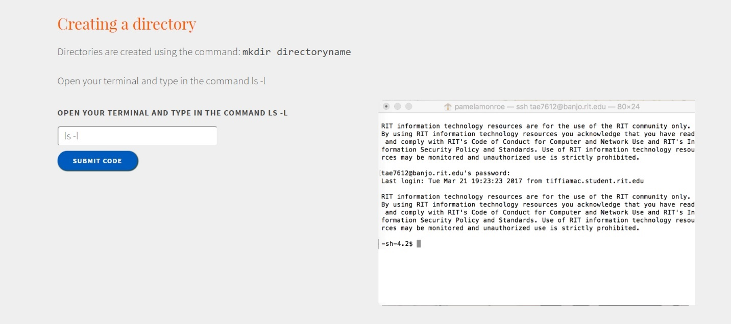

Figure 6: Command Terminal Screenshot – Before

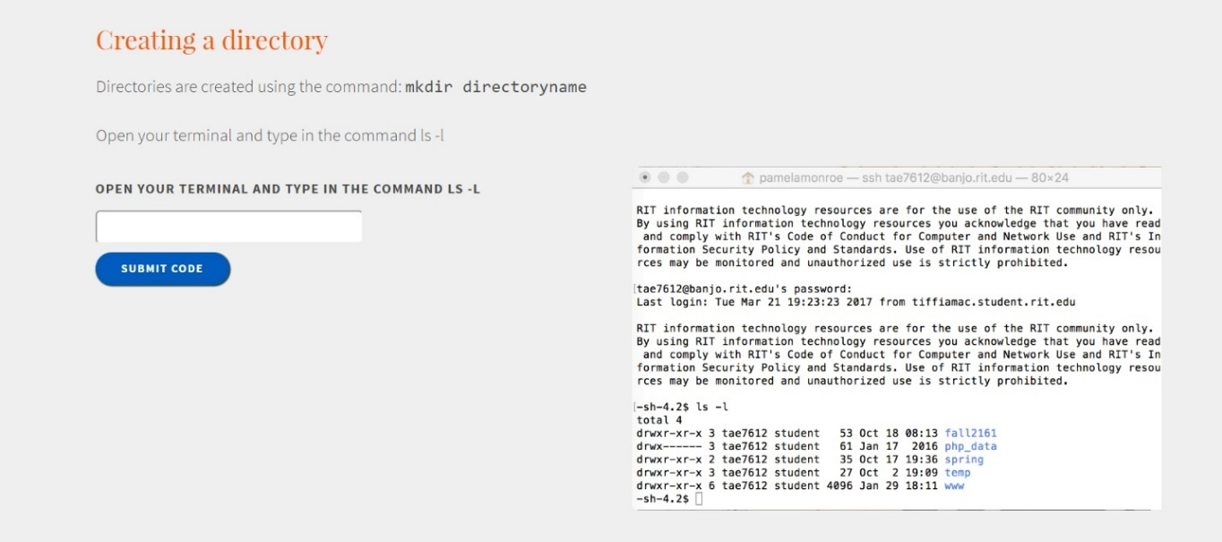

Figure 7: Command Terminal Screenshot – After

# WireFrames

## Desktop

### Home

This simplistic home page is welcoming to the user but doesn’t overwhelm them with information. The user has three ways of navigation from here, they can either use the search option at the top right, the global navigation at the top, or they can click on the arrow on the left and the local navigation for the tutorials will slide out allowing the user to get back to the tutorial they were previously on.

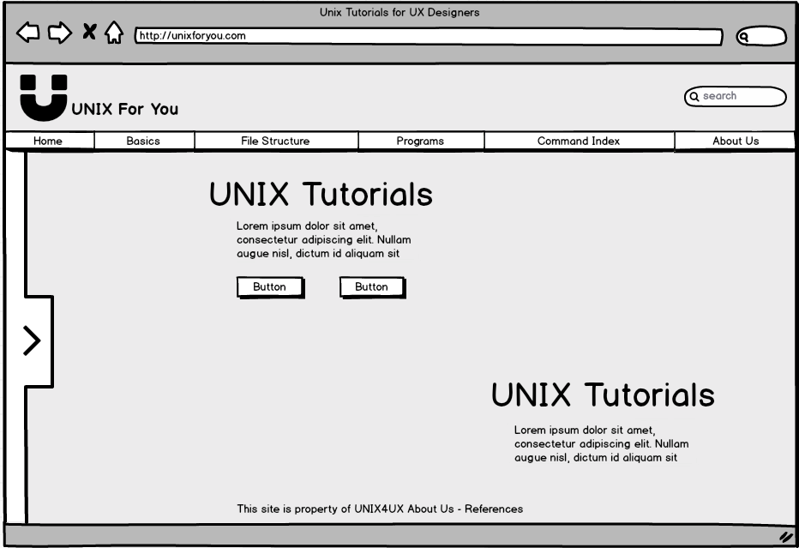

Figure 8: Wireframe - Desktop Home

This version of the home page displays what it would look like with the local navigation being displayed on the left. The content in the middle of the home page won’t have to move over for the local navigation for it already has enough of margin space to account for the local navigation.

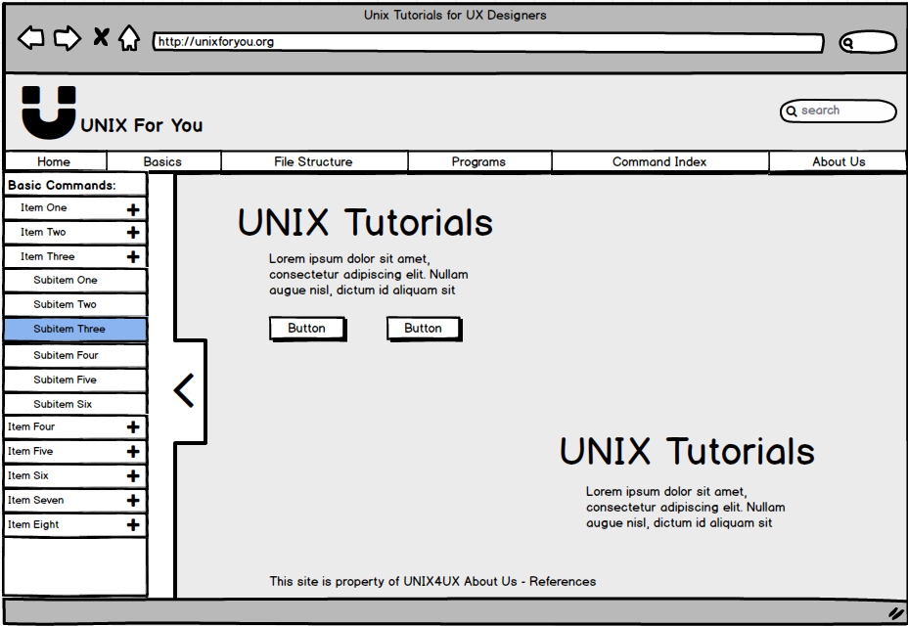

Figure 9: Wireframe – Desktop Home Slide-out

### Tutorial

The tutorial page is where the user will spend the most of their time, both the global navigation and the local navigation are also available for the user to use. The local navigation also serves as a breadcrumb trail. The user can follow the headers to see what they have done and what is ahead. For interactivity, the tutorial prompts the user to type into a text box, if they put in the correct thing the faux-terminal will display the result of the typed command.

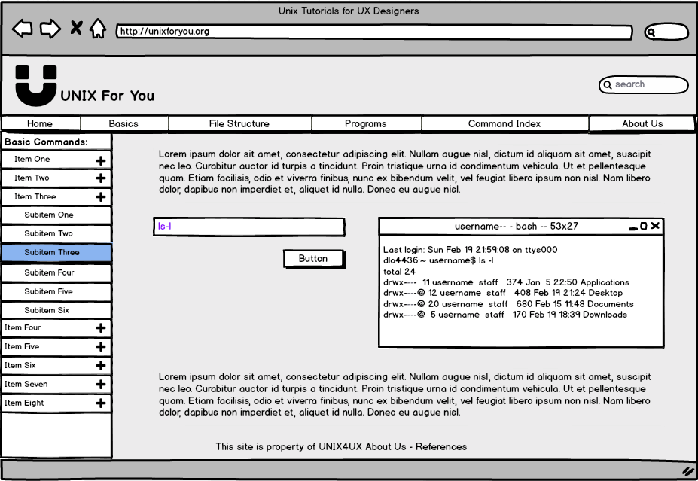

Figure 10: Wireframe – Desktop Tutorial

This version of the tutorial page is much like the previous one, however, this page shows the capacity of content that can be displayed at once. This page also shows another type in interactivity between the tutorial and the user. In this one, the user is learning how a directory is listed in Unix. Using the text box put to the side they can see the effects immediately on the changing image.

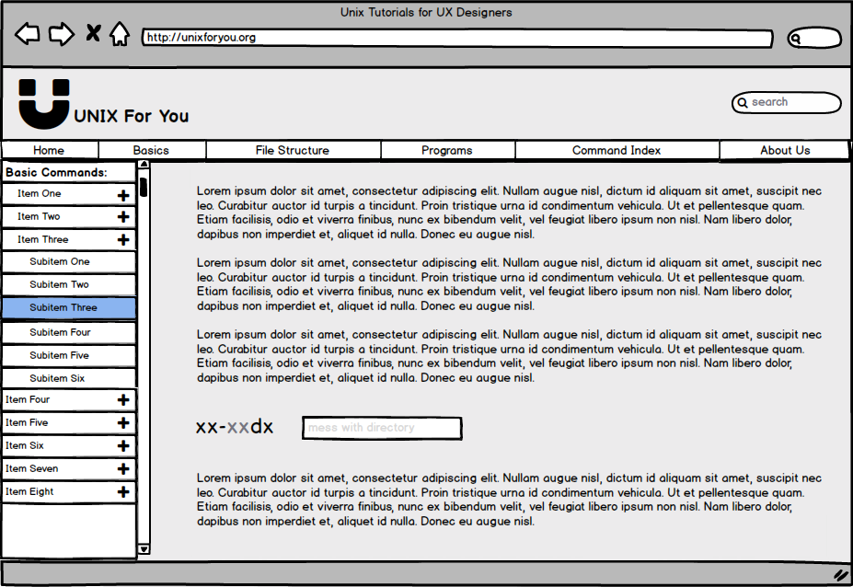

Figure 11: Wireframe – Desktop Tutorial 2

### Quiz

At the end of each major section, the user will be prompted to complete a quiz to ensure that they remember the material the section covered. All the questions will be aligned to the left. Questions will be asked in the form of checkboxes, radio buttons, and text input.

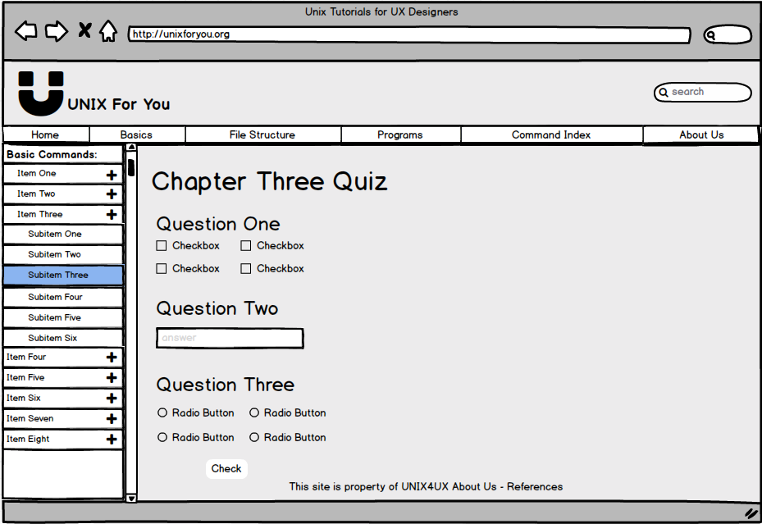

Figure 12: Wireframe – Desktop Quiz

### Index

The index is for the user to reference commands and a brief description that explains what it does. The bar with all the letters of the alphabet is used for the user to navigate throughout the index. When the user clicks on a letter, that letter will enlarge to show the user they are looking at that letter’s index.

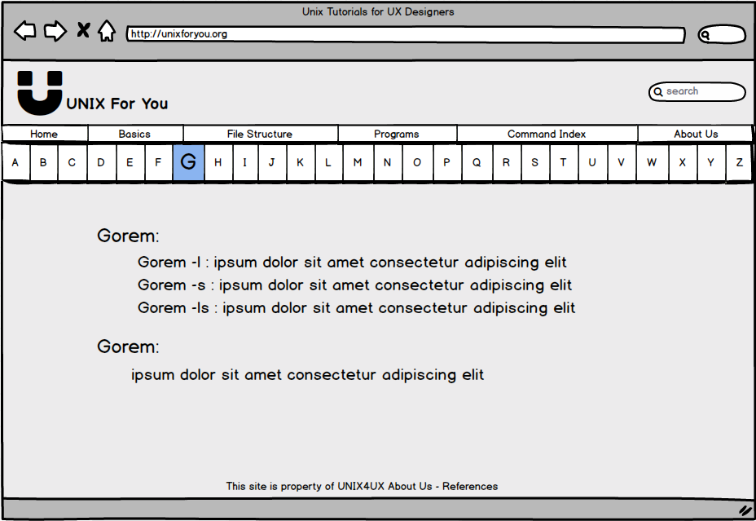

Figure 13: Wireframe: Desktop Index

### About Us

The about us page is a simple formality that allows the user to learn about the creators of the site, as well as how to contact us if need be. The page will have all the written content on the right side and pictures of us on the left.

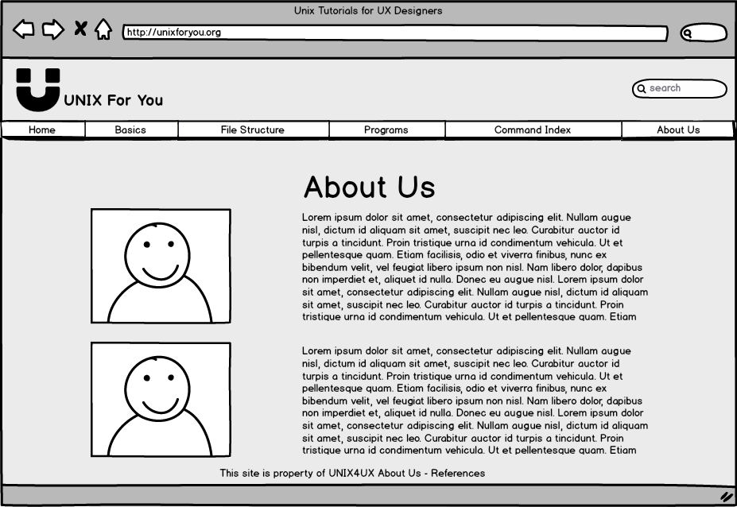

Figure 14: Wireframe - Desktop About Us

## Mobile

### Home

For the mobile version of our site, we have a static navigation that is displayed on the bottom. The home icon will take the user to the Home page (which is currently being displayed). The magnifying glass icon will take the user to a search page. The bookmark page will take the user to the menu page. The bars icon will take the user to the index page. The icon of multiple people will direct the user to the about us page.

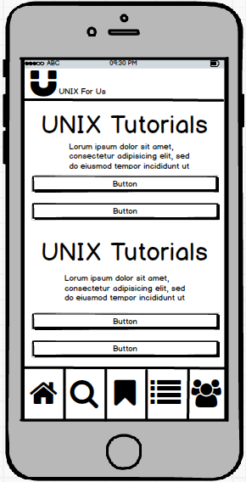

Figure 15: Wireframe - Mobile Home

### Menu

For the mobile menu page, users will be able to see each section that can be selected. Once they click on a section, they have the option of going to a more particular part of the section.

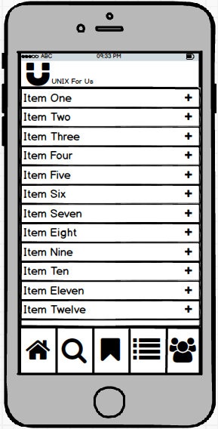

Figure 16: Wireframe - Mobile Menu

### Tutorial

For the mobile tutorial page, the user has similar capabilities as they would with the desktop version. There will be limited functionality because downloading too many images on a mobile site is not good practice.

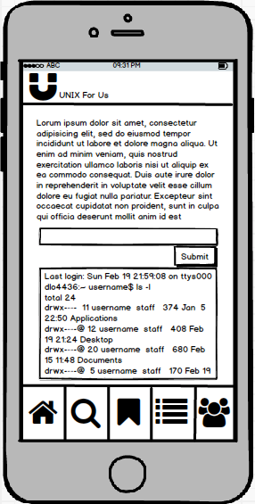

Figure 17: Wireframe - Mobile Tutorial

### Search

The mobile search page allows the user to search for a term. The results will direct them to any of the pages on the site that have the term that they searched for.

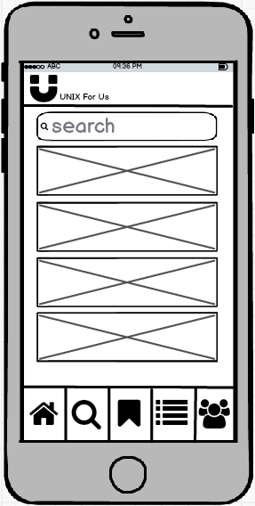

Figure 18: Wireframe - Mobile Search

### Quiz

Much like the desktop quiz page, the mobile quiz page prompts the user to test the knowledge of which they were just taught to ensure that they remember the info. For this version, however, the text and input options are aligned to the center.

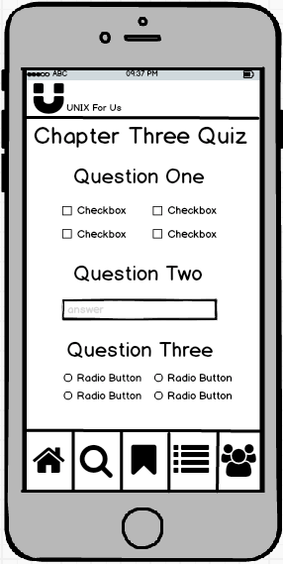

Figure 19: Wireframe - Mobile Quiz

### Index

The mobile version of the index displays all the terms in one large list much like a contact application of which mobile users are already familiar with. When the user selects a specific term, more info on the term is displayed. The alphabetical stack of letters on the right change to the corresponding content.

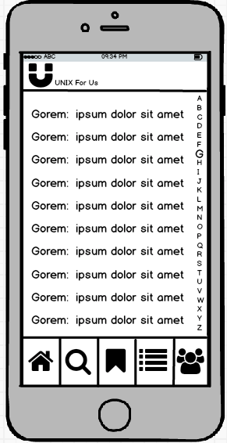

Figure 20: Wireframe - Mobile Index

### About Us

The mobile version of the about us page puts emphasis on the text and less on the photos for the sake of the user’s data consumption. The content allows the user to learn about the makers of the site as well as contact information so that they contact the makers for any reason they see fit.

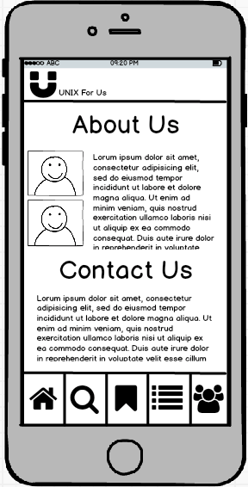

Figure 21: Wireframe - Mobile About Us

# Style Guide

Provided below are images of the basic elements of the site along with the HTML code required to create each element. Example pages are also provided. There are two design templates supplied.

## Style A

The styles are also available to interact with at these links:

* Homepage: <https://people.rit.edu/bab7607/ISTE240/GroupProjects/TeamProject1/index.html>
* About Us: <https://people.rit.edu/bab7607/ISTE240/GroupProjects/TeamProject1/about.html>
* Example Quiz: <https://people.rit.edu/bab7607/ISTE240/GroupProjects/TeamProject1/quizExample.html>
* Command Index: <https://people.rit.edu/bab7607/ISTE240/GroupProjects/TeamProject1/lookup.html>

### Color Palette

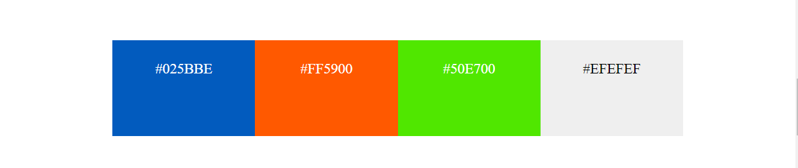

Figure 22: Style A - Color Palette

### Title

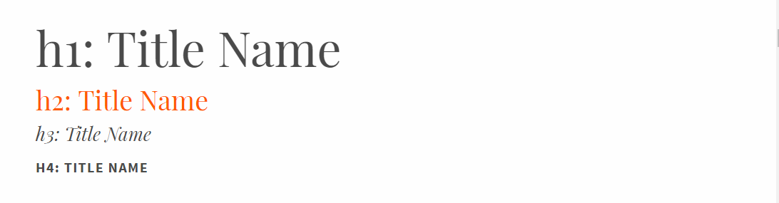

Figure 23: Style A – Titles

H1 is used for page titles. H2 is used for section titles. H3 is used for sub-headings. H4 is the lowest level sub-heading. Here is the html code used for creating titles:

<h1>Title Name</h1>

<h2>Title Name</h2>

<h3>Title Name</h3>

<h4>Title Name</h4>

### Paragraph

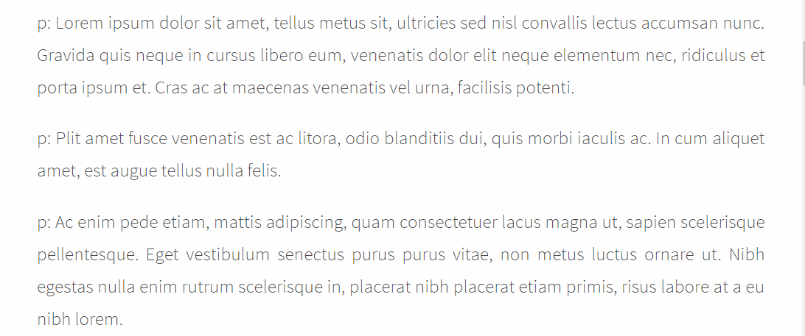

Figure 24: Style A – Paragraph

Paragraphs are used for page content. Here is the html code used for creating paragraphs:

<p>Lorem Ipsum</p>

<p>Lorem Ipsum </p>

<p>Lorem Ipsum </p>

### Buttons

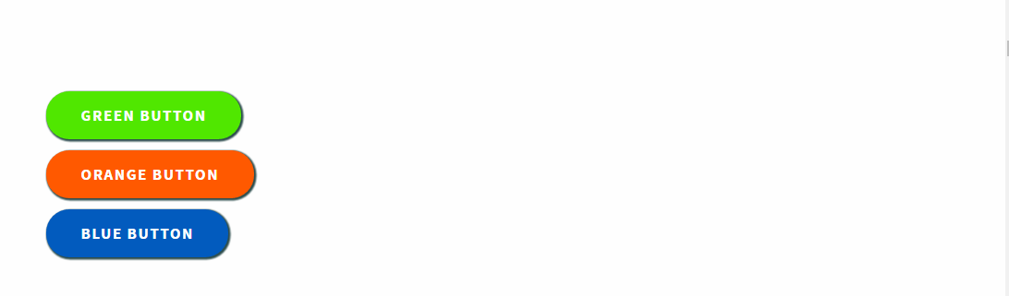

Figure 25: Style A – Buttons

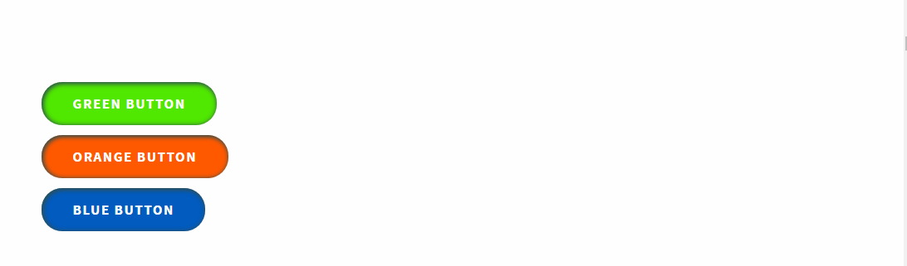

Figure 26: Style A – Buttons Hover

Buttons can be three different colors: green, orange, or blue. Buttons can also be horizontally aligned left, center, or right. Classes need to be applied to the button container and button to change the color and alignment.

Here is the code for an orange button aligned right:

<div class="button-container float-right">

<div class="button orange">

<a href="#">Button Text</a>

</div>

</div>

Here is the code for a blue button aligned left:

<div class="button-container float-left">

<div class="button blue">

<a href="#">Button Text</a>

</div>

</div>

Here is the code for a green button aligned center:

<div class="button-container float-center">

<div class="button green">

<a href="#">Button Text</a>

</div>

</div>

### Image



Figure 27: Style A – Image

Images have rounded corners and small shadow. No class need to be applied for the styling:

<img src="assets/images/image.png" alt="Picture" />

### Form Input

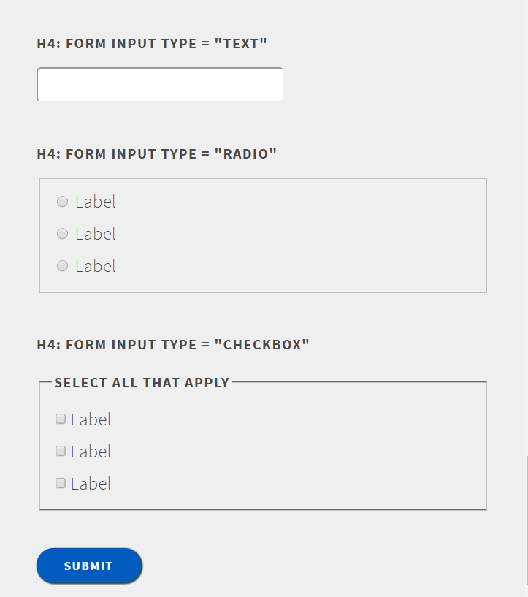

Figure 28: Style A – Forms

Forms are used to quiz the users and to allow the user to type commands and see the result. Only the following input types are allowed: text input, radio input, checkbox input, and submit button. The color of the submit button can be changed by adding the class “blue”, “green”, or “orange” to the input element. The submit button can also be horizontally aligned by added class “float-left”, “float-center”, or “float-right” to the input element.

Here is the code for a form with a text input, radio input, checkbox input, and submit button. The submit button is blue and aligned left:

<form>

<input type="text" name="blah" />

<fieldset class="radio-input">

<label for="blah"><input id=" blah " type="radio" name=" blah " value=" blah " /> Answer1</label>

<label for="blah"><input id=" blah " type="radio" name=" blah " value=" blah " /> Answer2</label>

</fieldset>

<fieldset>

<legend>Select all that apply</legend>

<input type="checkbox" name="blah" id=" blah " value="1"><label for=" blah ">Option1</label><br />

<input type="checkbox" name="blah" id=" blah " value="1"><label for=" blah ">Option2</label><br />

<input type="checkbox" name="blah" id=" blah " value="1"><label for=" blah ">Option3</label><br />

</fieldset>

<input class="blue float-left" type="submit" name="submit" value="Submit" />

</form>

### Header

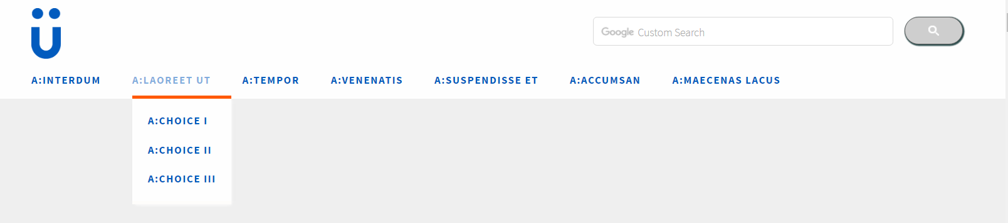

Figure 29: Style A – Header

The header includes the logo, a search area, and the global navigation.

* The logo is surrounded by figure tags. The figure tag has a class of “logo”.
* The search bar is contained in a div with an id of “search”. Copy and paste Google SCE code in the div.
* The global navigation supports sub elements. There are no classes required, however the structure of the html elements needs to be laid out exactly how it is below.

Here is the code for the header:

<header>

<figure class="logo">

<a href="#"><img src="assets/images/logo.png" alt="Logo"/></a>

</figure>

<div id="search">

Copy and paste code here from Google for a custom search bar

</div>

<nav>

<ul>

<li>

<div><a href="#">a:Interdum</a></div>

<ul>

<li><a href="#">a:Choice I</a></li>

<li><a href="#">a:Choice II</a></li>

</ul>

</li>

<li>

<div><a href="#">a:Laoreet Ut</a></div>

<ul>

<li><a href="#">a:Choice I</a></li>

<li><a href="#">a:Choice II</a></li>

</ul>

</li>

<li>

<div><a href="#">a:Tempor</a></div>

<ul>

<li><a href="#">a:Choice I</a></li>

<li><a href="#">a:Choice II</a></li>

</ul>

</li>

</ul>

</nav>

</header>

### Footer



Figure 30: Style A - Footer

There is a footer at the bottom of every page. The footer is very simple and contains only text. The footer section use the footer tags and the footer text is surrounded by paragraph tags. Here is the html code for the footer:

<footer>

<p>

This is example footer text.

</p>

</footer>

### Command Index Tabs

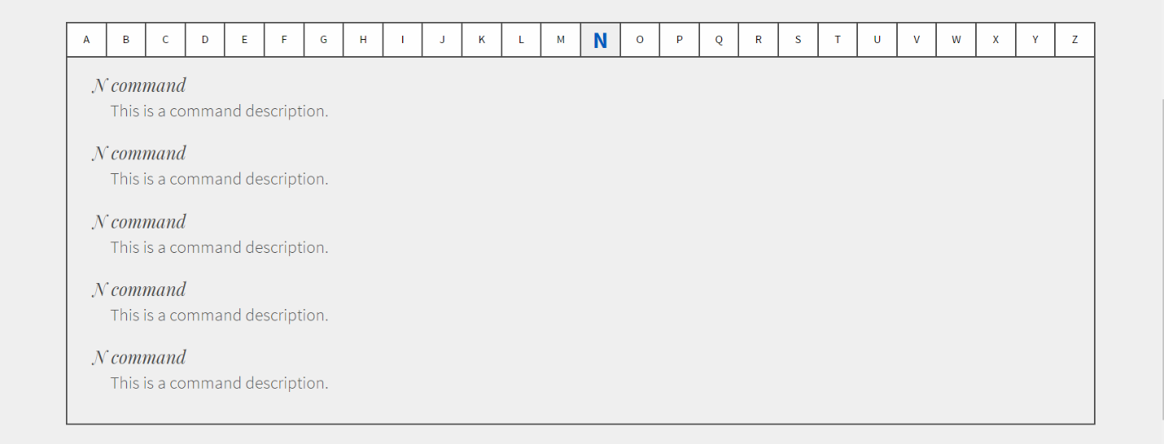

Figure 31: Style A - Command Index Tabs

The command index is organized using a tab structure. Here is the code:

<div class="tab">

<button class="tablinks" id="defaultOpen" onclick="openLetter(event, 'A')">A</button>

<button class="tablinks" onclick="openLetter(event, 'B')">B</button>

<button class="tablinks" onclick="openLetter(event, 'C')">C</button>

</div>

<div id="A" class="tabcontent">

<h3>A command</h3>

<p>This is a command description.</p>

</div>

<div id="B" class="tabcontent">

<h3>B command</h3>

<p>This is a command description.</p>

</div>

<div id="C" class="tabcontent">

<h3>C command</h3>

<p>This is a command description.</p>

</div>

### About Us

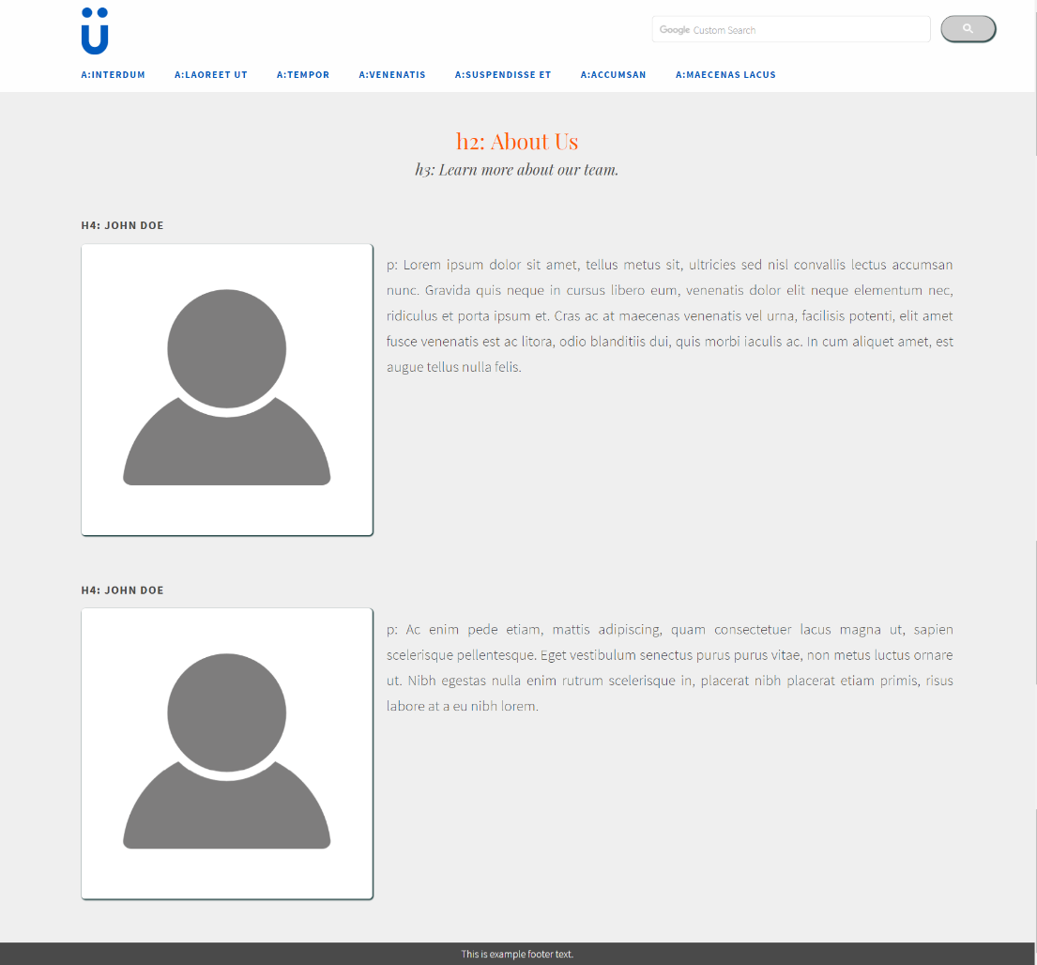

Figure 32: Style A - About Us

The about page style is used for the “About Us” page. The style uses h4 tags for the person’s name, an image tag, and a paragraph tag. Add the “about” class to the content div and the image and paragraph styles are automatically applied. Here is the code for the “About Us” page:

<div class="content about">

<div class="fullwidth">

<h2 class="float-center">h2: About Us</h2>

<h3 class="float-center">h3: Learn more about our team.</h3>

<h4>h4: John Doe</h4>

<img src="assets/images/profile.png" alt="Person" />

<p>

Lorem ipsum dolor sit amet, tellus metus sit, ultricies sed nisl c onvallis lectus accumsan nunc.

</p>

<h4>h4: John Doe</h4>

<img src="assets/images/profile.png" alt="Person" />

<p>

Ac enim pede etiam, mattis adipiscing, quam consectetuer lacus magna ut, sapien scelerisque pellentesque.

</p>

</div>

</div>

### Row Layout

There are multiple styles available for a row. Here are the four basic layouts.

#### Row 1



Figure 33: Style A - Row1

This is a left aligned row. The inner-most div has the class “one-half”. This row style incorporates a h1 element, h2 element, and a blue button. Here is the code:

<div class="wrapper">

<div class="content">

<div class="one-half">

<h1>Title Text</h1>

<h2>Title Text</h2>

<div class="button-container">

<div class="button blue">

<a href="#">Button Name</a>

</div>

</div>

</div>

</div>

</div>

#### Row 2

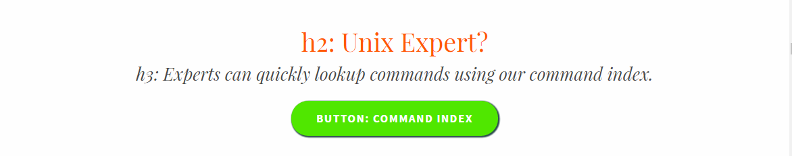

Figure 34: Style A - Row2

This is a center aligned row. The inner-most div has the class “fullwidth”. This row style incorporates a h2 element, h3 element, and a green button. All the title tags and button container have the class “float-center”. Here is the code:

<div class="wrapper">

<div class="content">

<div class="fullwidth">

<h2 class="float-center>Title Text</h1>

<h3 class="float-center>Title Text</h2>

<div class="button-container float-center">

<div class="button green">

<a href="#">Button Name</a>

</div>

</div>

</div>

</div>

</div>

#### Row 3



Figure 35: Style A - Row3

This is a right aligned row. The inner-most div has the class “one-half” and “float-right”. This row style incorporates a h2 element, h3 element, and an orange button. All the title tags and button container have the class “float-right”. Here is the code:

<div class="wrapper">

<div class="content">

<div class="one-half float-right">

<h2 class="float-right>Title Text</h1>

<h3 class="float-right>Title Text</h2>

<div class="button-container float-right">

<div class="button orange">

<a href="#">Button Name</a>

</div>

</div>

</div>

</div>

</div>

#### Row 4

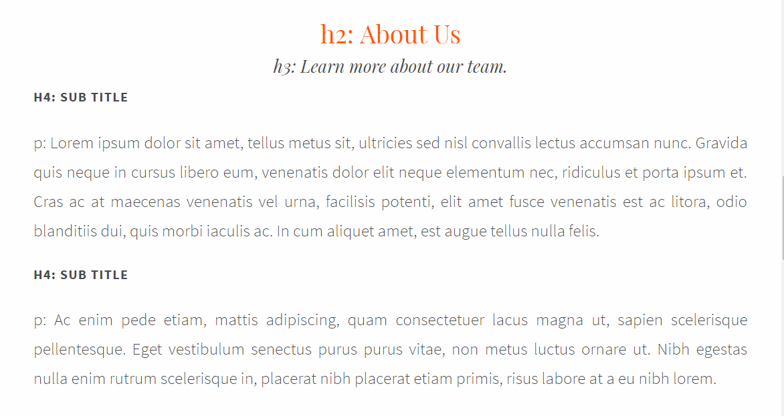

Figure 36: Style A - Row4

This row style is used when there is a lot of content in the section. This row style is used for the “About Us” page and the “Command Index” page. The titles are centered, but the content is aligned left. The inner-most div has the class “fullwidth”. This row style incorporates a h2 element, h3 element, h4 element, and paragraphs. The h2 and h3 tags have the class “float-center”. Here is the code:

<div class="wrapper">

<div class="content">

<div class="fullwidth">

<h2 class="float-center">Title</h2>

<h3 class="float-center">Sub-Title</h3>

<h4> Sub Title</h4>

<p>

Lorem ipsum dolor sit amet, tellus metus sit, ultricies sed nisl convallis lectus accumsan nunc.

</p>

<h4> Sub Title</h4>

<p>

Ac enim pede etiam, mattis adipiscing, quam consectetuer lacus magna ut, sapien scelerisque pellentesque.

</p>

</div>

</div>

</div>

### Example Page

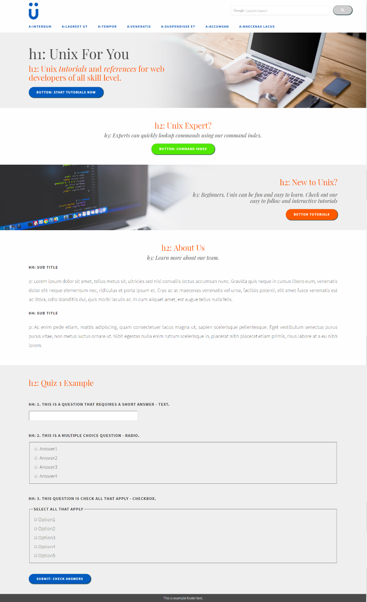

Figure 37: Style A - Page Example

Here is an example page that incorporates all the row styles, header, footer, titles, buttons, and form elements.

### Mobile Content

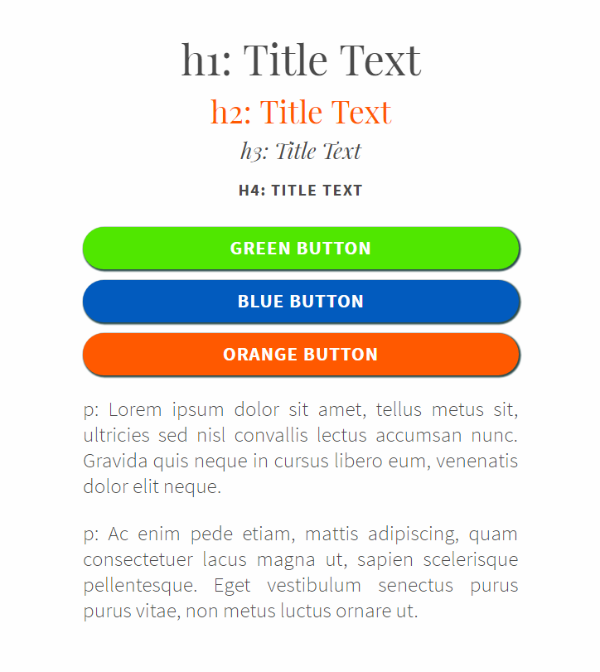

Figure 38: Style A – Mobile

This is the style for the mobile elements. All titles, buttons, and paragraphs automatically restyle, there are no additional styles needed. The titles align center. The buttons and all the content grow to 100% width.

## Style B

This is the second style option. All the HTML code is the same. The only coding difference is the button classes available to change the color of the button. The button class options are specified in the button section.

The styles are also available to interact with at these links:

* Homepage: <https://people.rit.edu/bab7607/ISTE240/GroupProjects/TeamProject2/index.html>
* About Us: <https://people.rit.edu/bab7607/ISTE240/GroupProjects/TeamProject2/about.html>
* Example Quiz: <https://people.rit.edu/bab7607/ISTE240/GroupProjects/TeamProject2/quizExample.html>
* Command Index: <https://people.rit.edu/bab7607/ISTE240/GroupProjects/TeamProject2/lookup.html>

### Color Palette

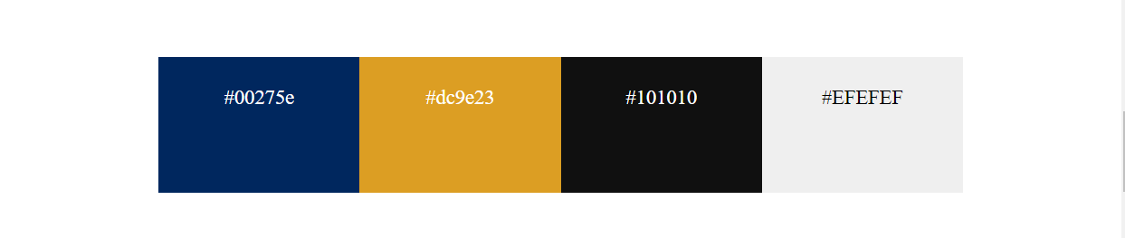

Figure 39: Style B - Color Palette

### Titles

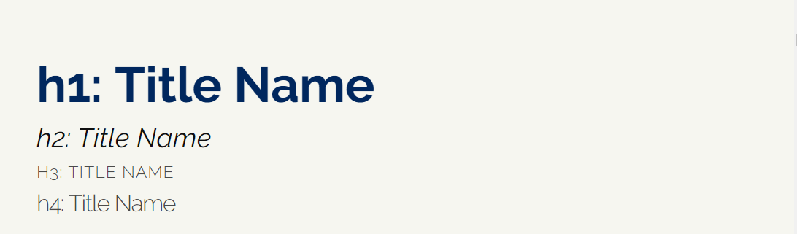

Figure 40: Style B – Titles

### Paragraph

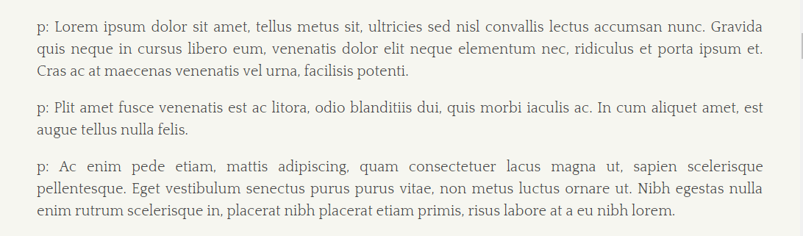

Figure 41: Style B - Paragraph

### Buttons

The button colors are “black”, “orange”, and “blue”.

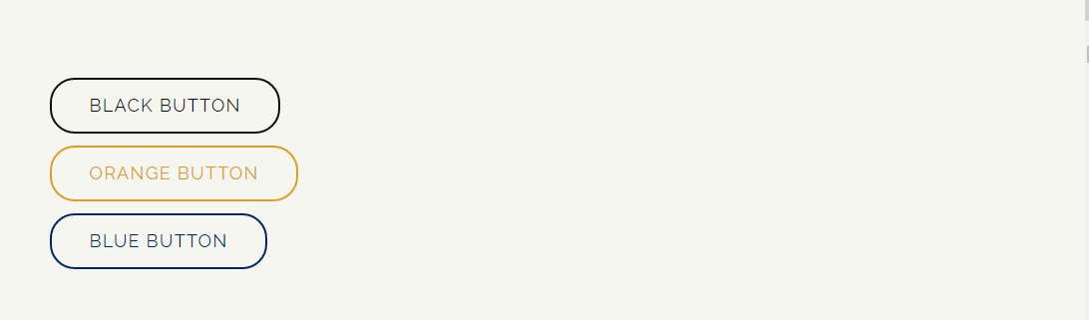

Figure 42: Style B – Buttons

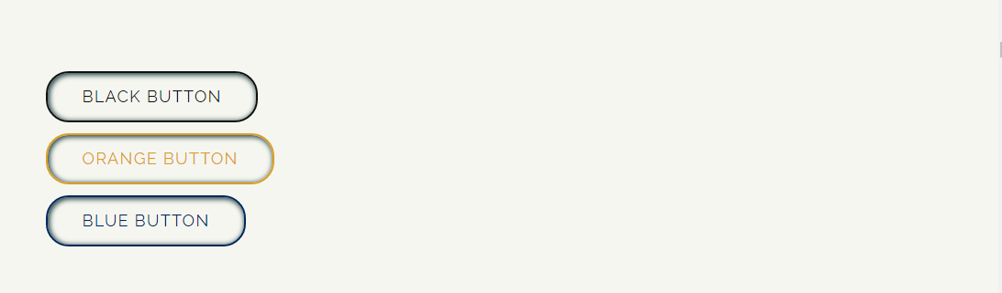

Figure 43: Style B - Buttons Hover

### Image



Figure 44: Style B – Image

### Form Input

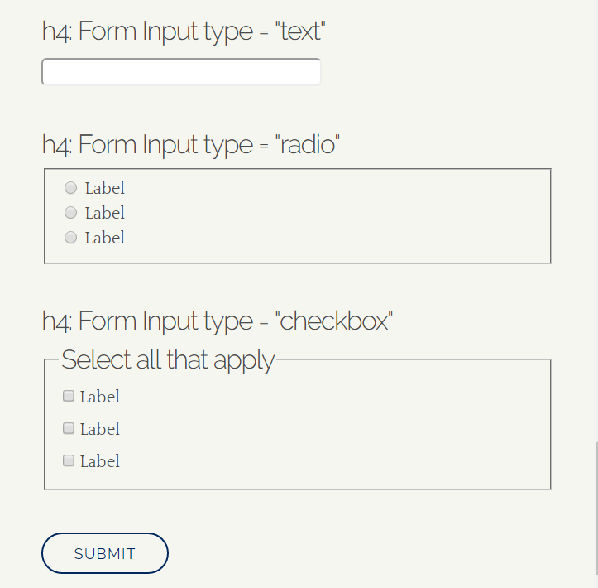

Figure 45: Style B – Forms

### Header

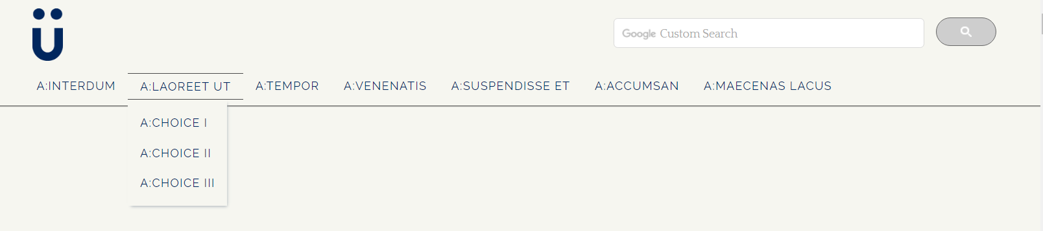

Figure 46: Style B – Header

### Footer



Figure 47: Style B – Footer

### Command Index Tabs

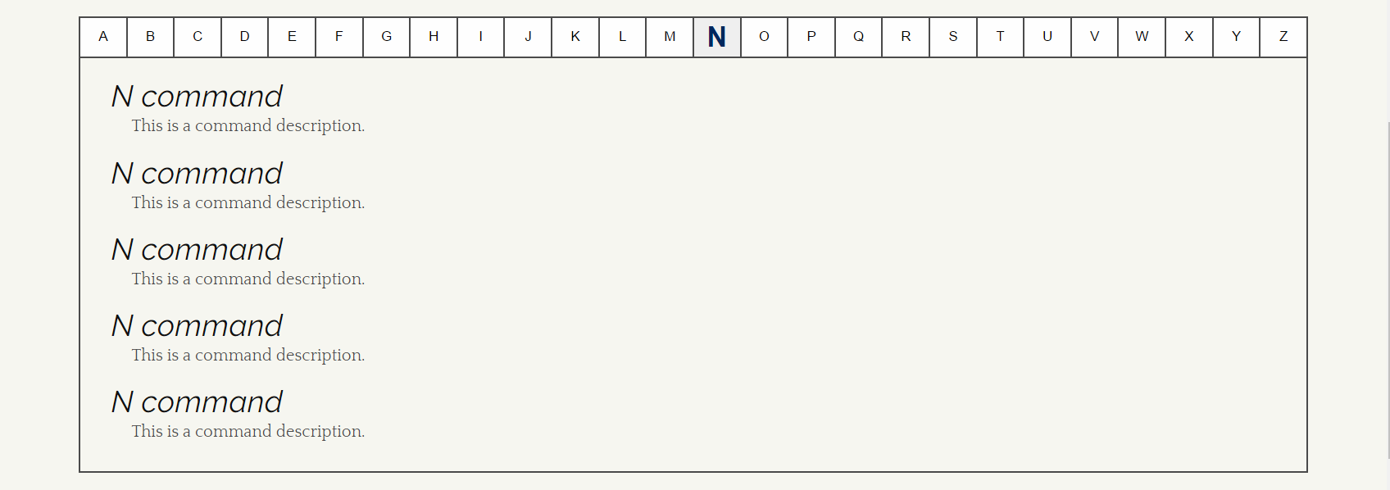

Figure 48: Style B - Command Index Tabs

### About Us

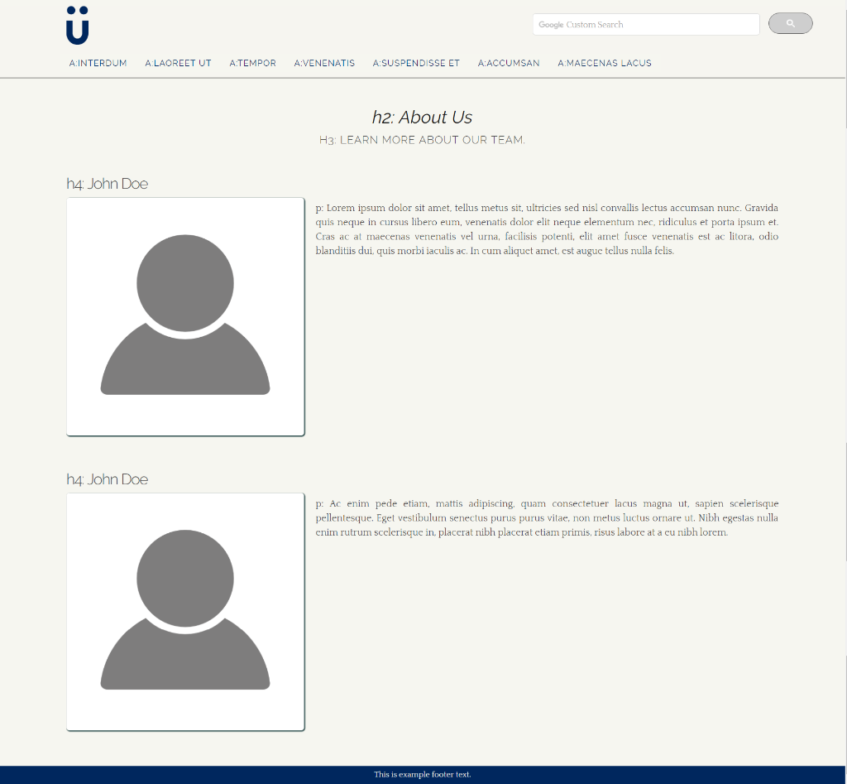

Figure 49: Style B - About Us

### Row Layout

#### Row 1

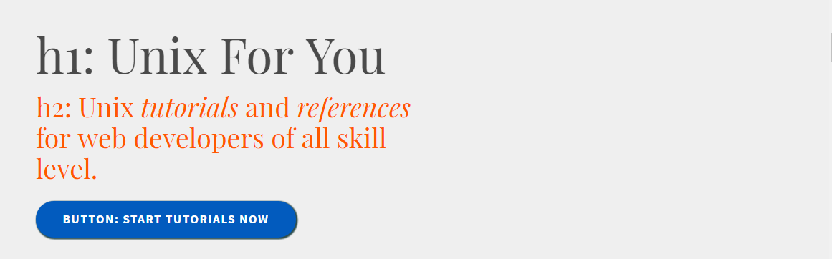

Figure 50: Style B - Row1

#### Row 2

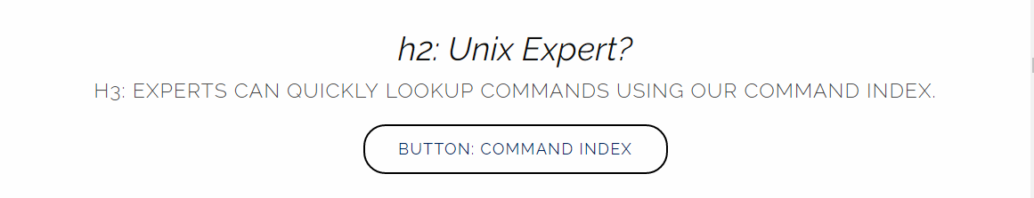

Figure 51: Style B - Row2

#### Row 3

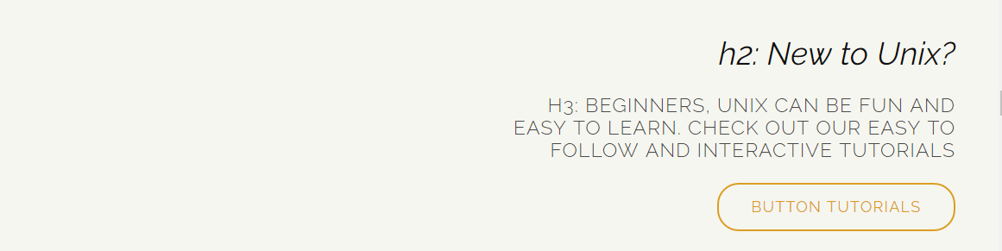

Figure 52: Style B - Row3

#### Row 4

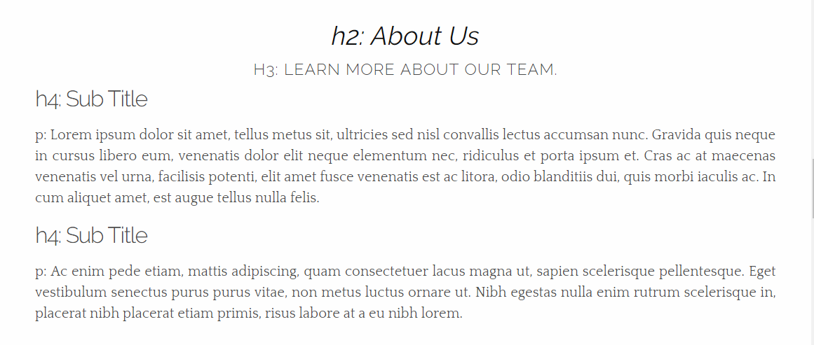

Figure 53: Style B - Row4

### Example Page

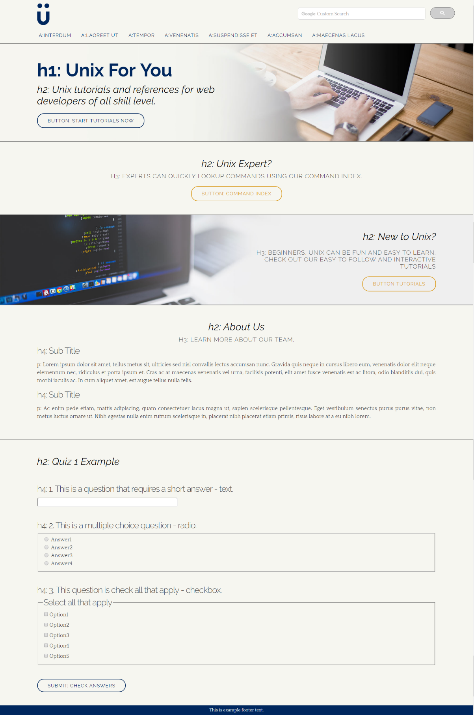

Figure 54: Style B – Page Example

### Mobile Content

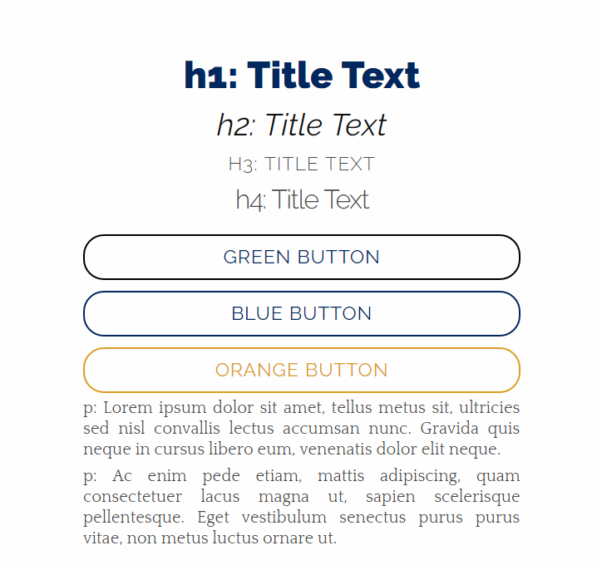

Figure 55: Style B - Mobile Content

# Images



Figure 56: Images – Logo



Figure 57: Images - About Us Mobile Menu Icon



Figure 58: Images - Home Mobile Menu Icon



Figure 59: Images - Index Mobile Menu Icon



Figure 60: Images - Search Mobile Menu Icon



Figure 61: Images - Tutorial Mobile Menu Icon



Figure 62: Images - Homepage Background Female



Figure 63: Images - Homepage Background Male



Figure 64: Images – Brianna



Figure 65: Images – Dan



Figure 66: Images - Matt



Figure 67: Images – Nate

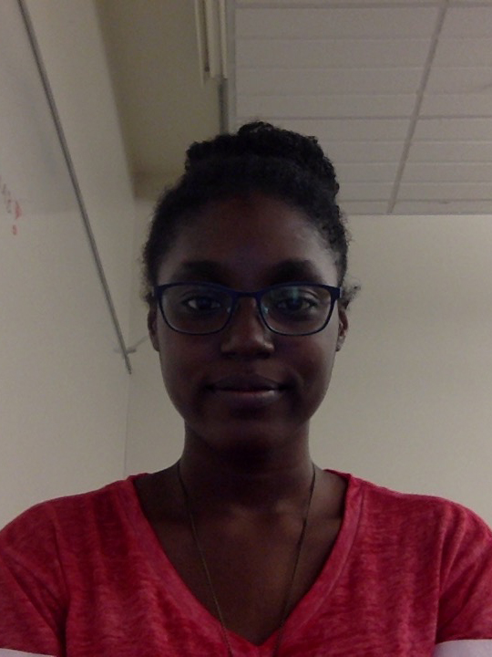

Figure 68: Images - Tiff



Figure 69: Images - Duncan

# Personas

## Jesse and Brenda

Jesse is currently a second-year college student majoring in Computer Science. She loves inspiring younger female students in her high school to major in technological fields. Brenda is a current 10th grader in high school who has taken an interest in learning more about computers.

### Scenario

Brenda reaches out to Jesse in hopes that she’ll explain what she’s learning in college so that Brenda can see if that's something she would want to study as well. After meeting, Jesse agrees to mentor her. Jesse tells Brenda that she should work on learning multiple programming languages. Jesse also tells Brenda that the first language she learned in college was Unix. Jesse gives her some sample problems and tells her to try to solve these problems on her own before they meet the following week. Brenda wonders if there are any online tools she can use so to help her get started. After a quick google search, she ends up on our Unix tutorial page. Brenda likes that our website offers quizzes and she feels that it is helpful for learning and understanding how Unix commands work.

## Derek

Derek is a first-year college student who is taking an introductory networking course. He doesn’t have prior knowledge on the topic and this is making him fall far behind the other students academically. Derek is quiet and keeps to himself so he doesn’t feel comfortable asking his classmates for help.

### Scenario

Derek is looking over his new networking assignment and sees that it is on Unix. He also notices that he’ll have to know the commands to make directors, move files, and change permission of some files. This makes him a little nervous because he has never worked in Unix before and doesn’t even know where to start. He goes to the lab so he can work on the assignment. He searches for Unix tutorials and finds our page. He looks at the homepage and reads the menu options to see if our site will be helpful. He sees the “Basic Unix” menu option and thinks this best describes what he needs. He clicks on the link and finds tutorials for working with directories and files, just what he needed. He feels that after these tutorials and online quizzes, he was ready for that week’s lab.

## Will

Will is a 32-year-old male who has decided to venture into the web development field after spending a large amount of his life in business. He decides to take a few courses in web-development. He sees that his first course is in a Mac lab but he only has experience working on a Windows computers.

### Scenario

Will is in his class and already feels uncomfortable being the oldest in the room. For this reason, he feels like he can’t connect with the other students as well as he’d hope. This week, Will sees that he’ll have to learn about Unix. He gets excited because he remembers some Unix commands from his younger years. When it comes time to do the assignment, he is having trouble with some of the commands’ syntax. After a search, he finds our Unix tutorial page and clicks on our “Index” menu. He loves that he can see the all the commands all on one page, that way he can just look specifically for the commands he needs.

## Julie

Julie is a 3rd year college student. She was just hired to work as a TA for an intro Web & Mobile course for the upcoming semester.

### Scenario

Julie receives an email from the professor she’ll be a TA for Introduction to Web & Mobile. In the email, the professor explains her responsibilities. As part of her job, Julie will have tutoring hours for those who need it. She is also given the lesson topics, so she decides to review all the material in preparation for tutoring. The first lesson topic is Unix. She starts looking for tools the students to help them if they get stuck. After searching for tutorial sites, she finds our page. She sees that we offer information on basic Unix commands, tutorials, quizzes, and an index page. She really like our site and feels that many students could learn from it. So, she emails the site to all the students as supplemental material to the course.

# Navigational Structure

## Sitemap

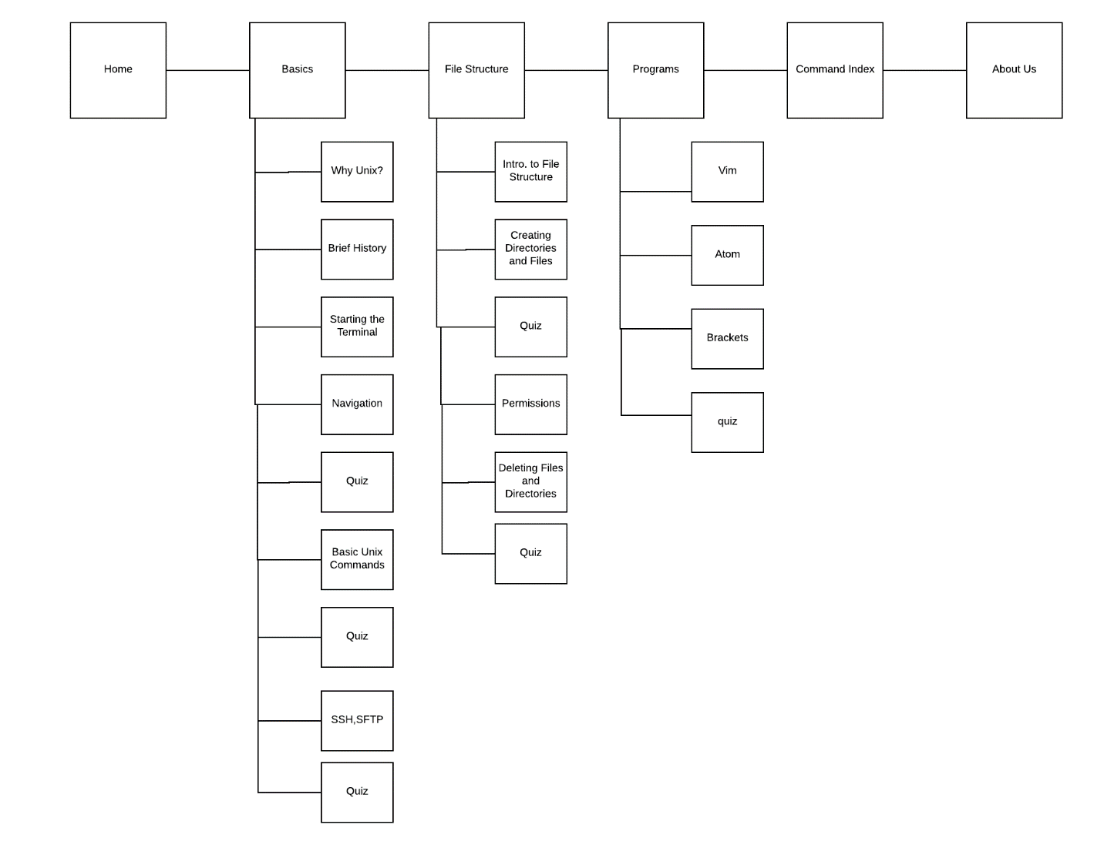

Figure 70: Sitemap

Conclusion

To fulfill the needs of the user, our website was designed with the goal of simplicity. The site allows the user to easily and quickly find the what they are looking for, whether that is a particular command in our expansive index or an explanation of how to do something in one of our in-depth tutorials. In these tutorials, we provide an interactive learning experience that helps our users fully understand the content. To ensure comprehension, we supply a quiz at the end of important sections that reinforces the course material. Navigating the site is intuitive on our site. The global navigation is separated by general topics, while the local navigation is located on the side and displays a more detailed list of all the topics available. If the user if using a mobile device, we have a static navigation bar located on the bottom that provides a better user experience. Satisfying the users of our website is easy with our clean design, easy to use navigation systems, and check-ins to be sure our users learn the content.

# References

A hackable text editor for the 21st Century. (n.d.). Retrieved March 27, 2017, from <https://atom.io/>

A modern, open source code editor that understands web design. (n.d.). Retrieved March 27, 2017, from <http://brackets.io/>

Absolute path vs relative path in Linux/Unix. (2016, March 15). Retrieved March 20, 2017, from [http://www.linuxnix.com/abslute-path-vs-relative-path-in-linuxUnix/](http://www.linuxnix.com/abslute-path-vs-relative-path-in-linuxunix/)

F. (n.d.). *Multiple users silhouette*. Retrieved March 20, 2017, from Multiple users silhouette. (n.d.). Retrieved March 20, 2017, from <http://www.freepik.com/free-icon/multiple-users-silhouette_736514.htm#term=people&page=1&position=26>  (Originally photographed 2015)

File types In Linux/Unix explained in detail. (2016, February 09). Retrieved March 20, 2017, from [https://www.linux.com/blog/file-types-linuxUnix-explained-detail](https://www.linux.com/blog/file-types-linuxunix-explained-detail)

FileZilla. (n.d.). Retrieved March 27, 2017, from <https://filezilla-project.org/>

Free stock photo of coder, computer, laptop. (n.d.). Retrieved March 20, 2017, from <https://www.pexels.com/photo/working-typing-macbook-computer-7350/>

Gandy, D. (n.d.). Fa-bookmark-o · Unicode: f097 · Created: v2.0 · Categories: Web Application Icons. Retrieved March 20, 2017, from <http://fontawesome.io/icon/bookmark-o/>

Gandy, D. (n.d.). Fa-home · Unicode: f015 · Created: v1.0 · Categories: Web Application Icons. Retrieved March 20, 2017, from <http://fontawesome.io/icon/home/>

Gite, V. (2013, October 06). Unix Create a File Command. Retrieved March 20, 2017, from [https://www.cyberciti.biz/faq/Unix-create-file-from-terminal-window-shell-prompt/](https://www.cyberciti.biz/faq/unix-create-file-from-terminal-window-shell-prompt/)

Guide to Unix/Commands/File System Utilities. (n.d.). Retrieved March 27, 2017, from <https://en.wikibooks.org/wiki/Guide_to_Unix/Commands/File_System_Utilities>

Introduction to the Mac OS X Command Line. (2015, May 21). Retrieved March 27, 2017, from <http://blog.teamtreehouse.com/introduction-to-the-mac-os-x-command-line>

List Icon. Retrieved March 20, 2017, from <https://cdn0.iconfinder.com/data/icons/layout-and-location/24/Untitled-2-21-128.png>

Jerry Peek, Tim O'Reilly & Mike Loukides. (1998, August 04). UNIX Power Tools. Retrieved March 20, 2017, from [http://docstore.mik.ua/orelly/Unix/upt/ch14_02.htm](http://docstore.mik.ua/orelly/unix/upt/ch14_02.htm)

Multiple users silhouette. (n.d.). Retrieved March 20, 2017, from <http://www.freepik.com/free-icon/multiple-users-silhouette_736514.htm#term=people&page=1&position=26>

Reys, G. (2008, March 19). Unix File Types. Retrieved March 20, 2017, from [https://www.Unixtutorial.org/2007/09/Unix-file-types/](https://www.unixtutorial.org/2007/09/unix-file-types/)

*Search*. (n.d.). Retrieved March 20, 2017, from <http://www.freeiconspng.com/free-images/search-icon-png-9985>

The UNIX® Evolution: An Innovative History. (2016, March 04). Retrieved March 27, 2017, from [https://blog.opengroup.org/2016/02/23/the-Unix-evolution-an-innovative-history/](https://blog.opengroup.org/2016/02/23/the-unix-evolution-an-innovative-history/)

The UNIX® Standard. (n.d.). Retrieved March 27, 2017, from [http://opengroup.org/Unix](http://opengroup.org/unix)

T. (n.d.). Unix File Management. Retrieved March 20, 2017, from [https://www.tutorialspoint.com/Unix/Unix-file-management.htm](https://www.tutorialspoint.com/unix/unix-file-management.htm)

T. (n.d.). Unix File System Basics. Retrieved March 20, 2017, from [https://www.tutorialspoint.com/Unix/Unix-file-system.htm](https://www.tutorialspoint.com/unix/unix-file-system.htm)

UNIX Tutorial Two. (n.d.). Retrieved March 20, 2017, from [http://www.ee.surrey.ac.uk/Teaching/Unix/Unix2.html](http://www.ee.surrey.ac.uk/Teaching/Unix/unix2.html)

The UNIX® Standard. (n.d.). Retrieved March 27, 2017, from [http://opengroup.org/Unix](http://opengroup.org/unix)

Vim - the ubiquitous text editor. (n.d.). Retrieved March 27, 2017, from <https://Vim.sourceforge.io/>